**Lab2 Image Processing**

Jiabao Liu

025354255

11/2/2015

Objectives:

1. Select a set of at least 20 images (e.g. faces, hands, finger prints, or other biometric)
2. Process the images and convert them into feature vectors. You can use matlab for this. You need to show how you pre-process the images, what image processing techniques you apply, and what features from the image you use to create the feature vectors.

Results:

1. Select a set of at least 20 images.

20 faces images are downloaded from website, and named through ‘a.pgm’ to ‘t.pgm’. Also, all images are 112*92 unit8 in grey scale. Here is an example of one face.

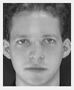

1. Choose the average pixel in every row as feature vectors, then save to text file.

Since the image size is 112*92, so there will be 112 feature vectors for each image. Also, since choosing 20 persons as training set, the matric size of training set is 20*112.

Matlab code.

 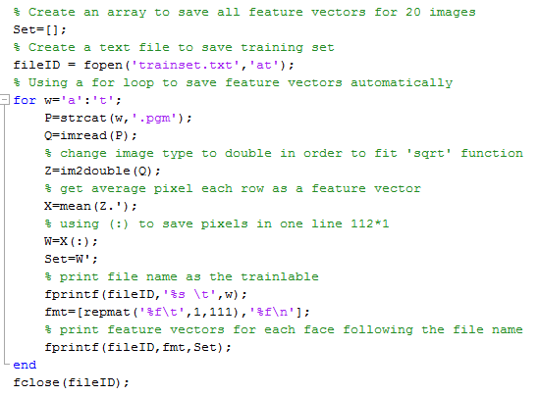

Read images ‘a.pgm’ to ‘t.pgm’ using a for loop, then change image type from ‘unit8’ to ‘double’, because ‘sqrt’ function can’t be used for type ‘unit8’. Finally save matrix to a text file named ‘traintest.txt’, and the result 20*112 matrix is shown as below:

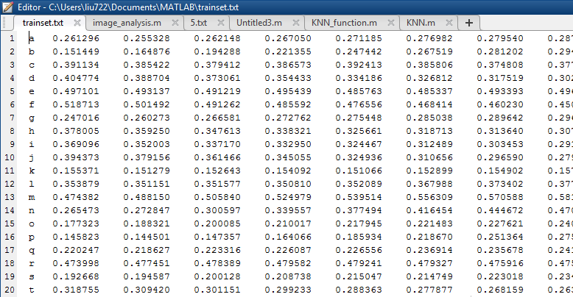

1. In the same way, get the ‘testset.txt’ file. For testset, only choose 3 faces as test. I changed several numbers to make sure they are not excetly same with training set. Then read those two files, choose first column as the lables, the numerical matrix as the feature vectors for each face. Combined with KNN function, finally get the predicted result. 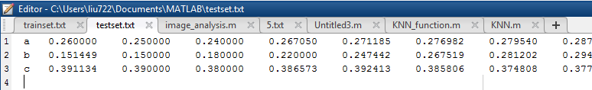

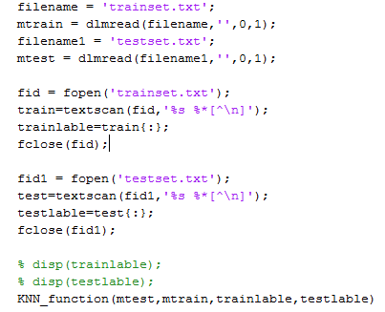

The result is shown below:

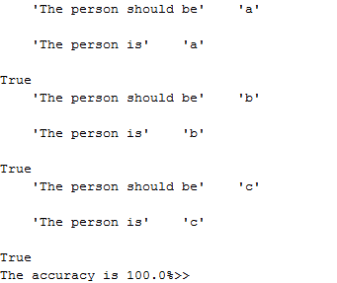

1. The result shows that the accuracy is 100%. However, the feature vector still has a lot need to be improved.